Abrazos Rotos, Los (Broken Embraces) (127 min.) In Spanish
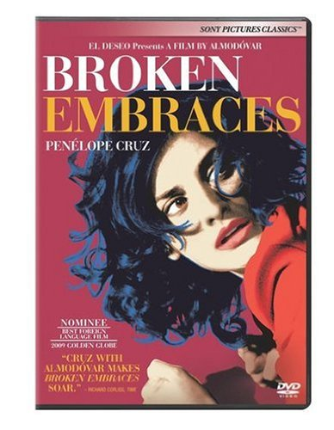

In Madrid, Harry Caine is a blind screenwriter, assisted by Judit and her son Diego. The past comes rushing in when Harry learns of the death of Ernesto Martel, a wealthy businessman, and Ernesto’s son pays Harry a visit. In a series of flashbacks to the 1990s, we see Harry, who was then Mateo Blanco, a director; he falls in love with Ernesto’s mistress, Lena, and casts her in a film, which Ernesto finances. Ernesto is jealous and obsessive, sending his son to film the making of the movie, to follow Lena and Mateo, and to give him the daily footage. Judit doesn’t like Lena. It’s a collision course.
Abre Los Ojos (Open Your Eyes) (117 min.) In Spanish
Eduardo Noriega is a rich womanizer who prowls the parties and bars of Madrid, intent on bagging chicks. But when Noriega falls for the beautiful Sofia, he is the one who is bagged.
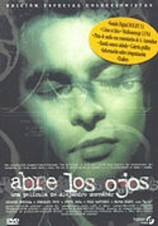

Agora (126 Minutes) In English

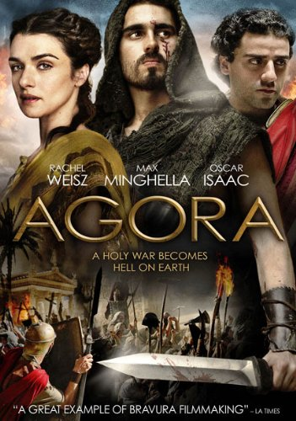
A historical drama set in Roman Egypt, concerning a slave who turns to the rising tide of Christianity in the hope of pursuing freedom while falling in live with his mistress, the famous philosophy and mathematics professor Hypatia of Alexandria.
Alatriste (145 Minutes) Subtitles

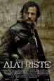
Viggo Mortensen plays the Spanish soldier-turned-mercenary Captain Alatriste, a heroic figure from the country's 17th century imperial wars.

Amor Brujo, El (Bewitched Love) (103 Minutes) In Spanish
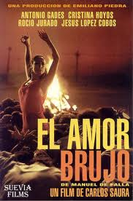

In a Gypsy village, the fathers of Candela and José promise their children to each other. Years later, the unfaithful José marries Candela but while defending his lover Lucía in a brawl, he is stabbed to death. Carmelo, who secretly loves Candela since he was a boy, is arrested while helping José and unfairly sent to prison. Four years later he is released and declares his love for Candela. However, the woman is cursed by a bewitched love and every night she goes to the place where José died to dance with his ghost.

Anuncios, Senales, y Carteles (17 Minutes) **
Test your reading comprehension skills and have fun looking at a wide variety of signs found in the Spanish-speaking world
Barcelona (30 Minutes) In English

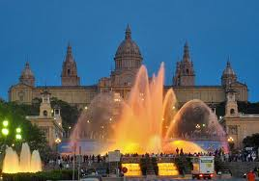

One of the most modern cities in the world, Barcelona maintains a strong sense of identity as the capital of Catalonia and is fiercely loyal to its cultural traditions. Above all, Barcelona is a city of contrasts, in which the ancient and contemporary are beautifully combined.

Belle Epoque (110 Minutes) Subtitles

In 1931, a young soldier (Fernando) deserts from the army and falls into a country farm, where he is welcomed by the owner (Manolo) due to his political ideas. Manolo has four daughters (Rocio, Violeta, Clara and Luz). Fernando likes all of them and they like him, so he has to decide which one to love.

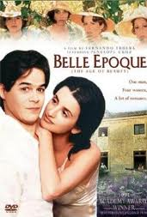

Bienvenido Mister Marshall (78) Spanish

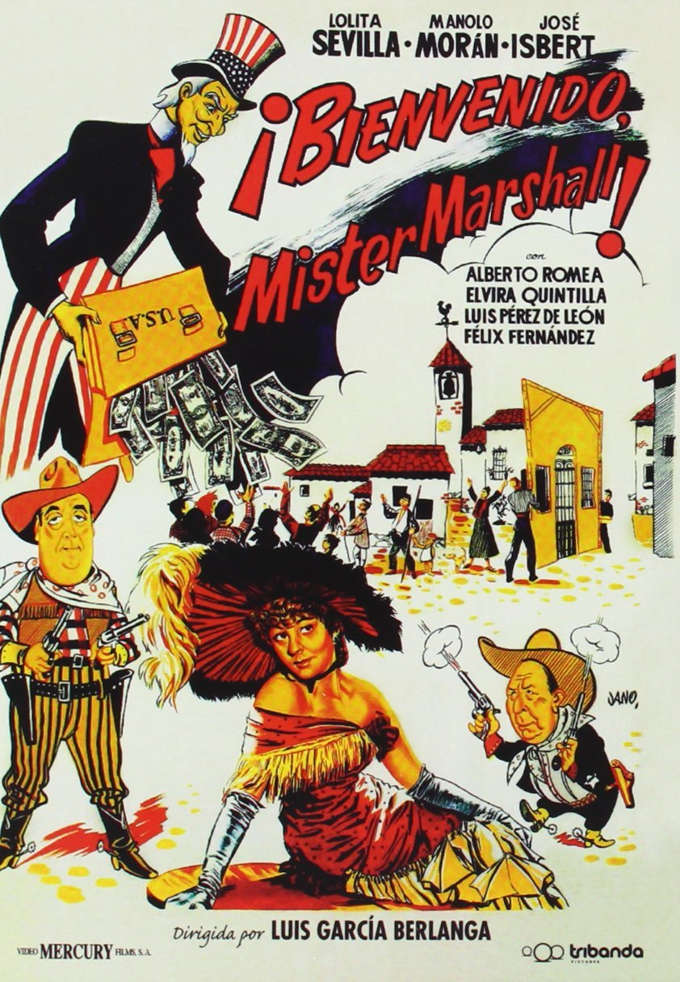
After finding out that North American people are visiting the Spanish villages, the citizens of Villar del Rio start preparing themselves to welcome them when they arrive.

Bodas de Sange (Blood Wedding) (71 Minutes) Subtitles
Bodas de Sangre centers around the struggle of Leonardo, a man who is married and has one child, with another to be born soon, but who is still in love with his ex-girlfriend of 3 years. He even rides his horse so hard that everyone has noticed, and his "suegra" tells him that he will ride the horse to death: he is secretly riding out to where the "novia" lives. She is also still in love with him, but is attempting to put the past behind her and is getting married to another man. However, on the day of her wedding, she becomes agitated, as she realizes what she is getting herself into with "el novio" and that she in fact does not love him nor wishes to marry him. She and Leornardo finally run away together, but the play ends in tragedy, with the death of both Leornardo and el novio, fighting (off-screen, in the tradition of the ancient Greek tragedies) for honor.
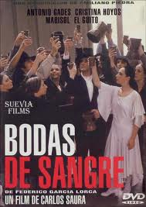
Butterfly’s Tongue (95 Minutes) Subtitles
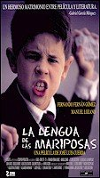
The film centers on Moncho and his coming-of-age experience in Galicia in 1936. Moncho develops a close relationship with his teacher Don Gregorio, who introduces the boy to different things in the world. While the story centers on Moncho’s ordinary coming-of-age experiences, tensions related to the looming Spanish Civil War periodically interrupt Moncho’s personal growth and daily life.

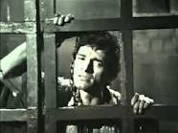
Calderon de la Barca: La Vida es Sueño (Life is a Dream) (74 Minutes) In Spanish

Life is a Dream (Spanish: La vida es sueño) is a Spanish language play by Pedro Calderón de la Barca. First published in 1635 (or possibly early in 1636),^{[1]} it is a philosophical allegory regarding the human situation and the mystery of life.^{[2]} Focusing on Segismundo, Prince of Poland, the central argument is the conflict between free will and fate.

Cantar de mio Cid (The Song of my Lord) (60 Minutes) In Spanish
Short film based on the oldest epic Castilian poem. Based on a true story, it tells of a Spanish hero El Cid, whose true name was Rodrigo (or Ruy) Díaz de Vivar during re-conquest of Spain from the Moors. El Cid married the cousin of King Alfonso VI, Doña Ximena, but for certain reasons, he fell into the disfavor of the king and had to leave his home country Castile. The story tells of the Cid's unjust banishment from the court of King Alfonso, his victorious campaigns in Valencia, and the crowning of his daughters as queens of Aragon and Navarre the high point of his career as a warmonger. An epic that sings of universal human values, this film illustrates one of the greatest of all works of Spanish literature.

Cantigas de Santa Maria, Las (33 Minutes) In Spanish

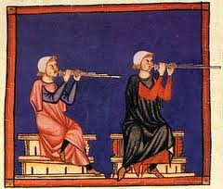

A video documentary on las Cantigas de Santa Maria or Canticles of Santa Mary, produced under the patronage of King Alfonso X, el Sabio or the Learned. Combining images, music and poetry from the illuminated manuscripts, with short on-camera interviews with American specialists, the documentary focuses on the area and history present in this monumental work of the Spanish Middle Ages.

Carmen (101 Minutes) Subtitles

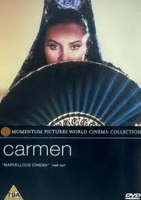

Antonio Gades plays a choreographer who gets involved with his neophyte lead dancer (Laura del Sol) and grows dangerously jealous. Depicting the joys and anguishes of their affair in between rehearsals for Gades’s ballet, Carmen is a visually hypnotic hall of mirrors in which the dancers become inseparable from their personae.

Celestina, La (92 Minutes) Subtitles
The young nobleman Calisto falls in love with Melibea, the daughter of a rich merchant. Calisto's servant Sempronio suggests they get the sorceress Celestina to further the romance. However Calisto's other servant Parmeno is suspicious of Celestina, as he knows about her tricks. After Celestina convinces Melibea of Calisto's love and arranges a brief clandestine meeting between them, Calisto gives Celestina a valuable chain of gold. Both servants are not satisfied with the whores supplied by Celestina and demand more from her, thus setting off a dramatic sequence of events.
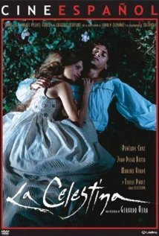
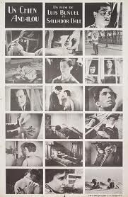
Chien Andalou, Un (Land Without Bread) (51 Minutes) Silent

Two masterpieces by influential Spanish surrealist Luis Buñuel. “Un Chien Andalou,” Buñuel’s first film, continues to shock audiences as it did in 1928 with its provocative imagery, including the infamous cutting open of an eye with a straight razor. “Land Without Bread” is a horrifying account of one of Spain’s most desolate and poverty-stricken rural regions, Las Hurde.

Cid, El (188 Minutes) In English
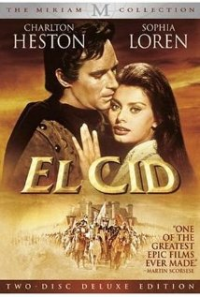

Epic film of the legendary Spanish hero, Rodrigo Diaz ("El Cid" to his followers), who, without compromising his strict sense of honor, still succeeds in taking the initiative and driving the Moors from Spain.

Cities of Light (116 Minutes) In English
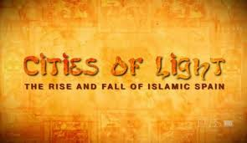

Over a thousand years ago, the sun-washed lands of Southern Spain were home to Muslims, Christians, and Jews living together and flourishing. Their culture and beliefs intertwined and the knowledge of the ancients was gathered and reborn. Here were the very seeds of the Renaissance. But this world too quickly vanished. Greed, fear, and intolerance swept it away. Puritanical judgments and absolutism snuffed out the light of learning. The Rise and Fall of Islamic Spain explores the causes that destroyed the one civilization of pluralism and interfaith that lit the Dark Ages of Medieval Europe.

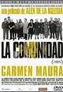
Comunidad, La (Common Wealth) (110 Minutes) (Subtitles)
Julia finds 300 million pesetas hidden in a dead man's house while selling an apartment. She's a 40-ish real estate agent now forced to face the wrath of a very peculiar community (of neighbors), headed by an unscrupulous administrator. Black humor gives way to suspense, closely followed by horror that doesn't take long in coming to a head in undisguised pandemonium.

Dali, Salvador (75 Minutes) In Spanish
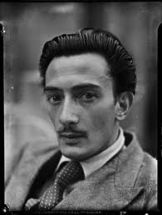

Presents Dali’s entire work--painting, sculpture, writing, fashion and film—in the context of his extraordinary life and career. Constructed through a combination of specially shot location footage, archive film, feature film material and interviews with Dali’s friends and colleagues.

Demonios en el Jardin (Demons in the Garden) (115 Minutes) In Spanish

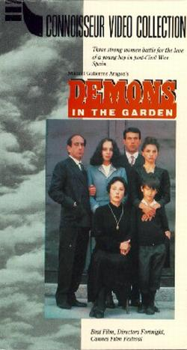
Demons in the Garden dwells upon three generations of an agrarian Spanish family. Most or all the family members have come of age since their country's Civil War. Fact becomes legend and legend becomes fact concerning that conflict, while the family is destroyed from within by corruption and long-smoldering rivalries. All of this is told from the point of view of the youngest (and, we are to assume, least emotionally damaged) family member.
Don Juan en los Infiernos (Don Juan in Hell) (105 Minutes) In Spanish
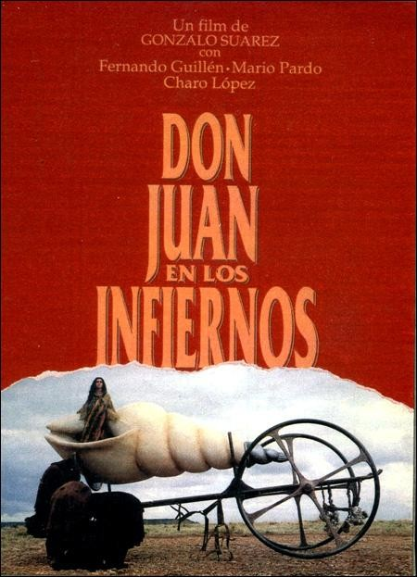

Beautiful, imaginative, poetic and almost surrealistic approach to Don Juan in his late years. Rich in powerful images like a giant shell being carried on wheels across the fields or in front of ancient buildings. The man who has found it in the sea is accompanied by his living shadow impersonated by a masked person who makes the same movements. Herald of sensual and intellectual freedom in a decadent empire tormented by religious fears and the concept of sin, Don Juan seeks reconciliation with his legitimate wife and his father, as he seems to prepare for a change in his way of living, or perhaps even his death. He is accompanied by his loyal servant Esganarel, that suffers much of his master's leg work (and other unpleasant situations) but at least is treated like a human being, almost a friend, by a Don Juan that foreshadows modern thinking.

Felipe de Borbon (19 Minutes) In Spanish
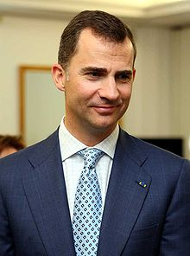
This January 1988 report presents a close up of the handsome heir to the Spanish throne on his 20th birthday. Mixing glimpses of personal family life with scenes of formal royal occasions, the program shows Prince Felipe’s life, from his baptism through school and military service. It ends with another birthday note-an orchestra led cellist Rostropovich sings Happy Birthday (in Spanish, of course) to King Juan Carlos on his 50th birthday.

Flores de Otro Mundo (Flowers from Another World) (100 Minutes) Subtitles
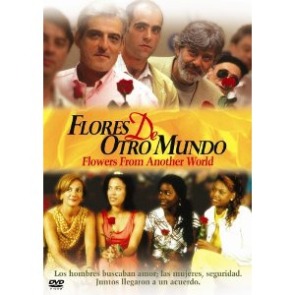

Flores de otro mundo tells the story of Santa Eulalia, a small Castilian town that is losing many of its jobs and young people to corporate agriculture and the lure of big cities. The older men of the town, desperate to find mates, organize a three-day celebration for prospective single women from all across Spain. The women arrive in a single bus. About half of them are light-skinned Spanish women, while the other half is made up of younger, darker-skinned women from the Dominican Republic.
The Garden of Delights (95 Minutes) In Spanish
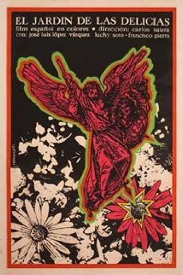
The greedy relatives of an amnesic and paralytic 45 years old millionaire tries to get him to recover his memory by any means.

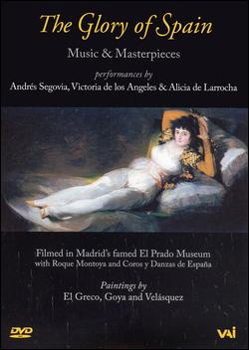
Glory of Spain, The (54 Minutes) In English

This video presents a performance by a renowned classical music trio at Madrid's El Prado Museum. The musicians include Andres Segovia, guitar, Alicia de Larrocha, piano, and Victoria de Los Angeles, soprano. The beauty of the music is set off by the fabulous art collection of Spain's most famous museum.

Goya (Museum without Walls) (54 Minutes) In English
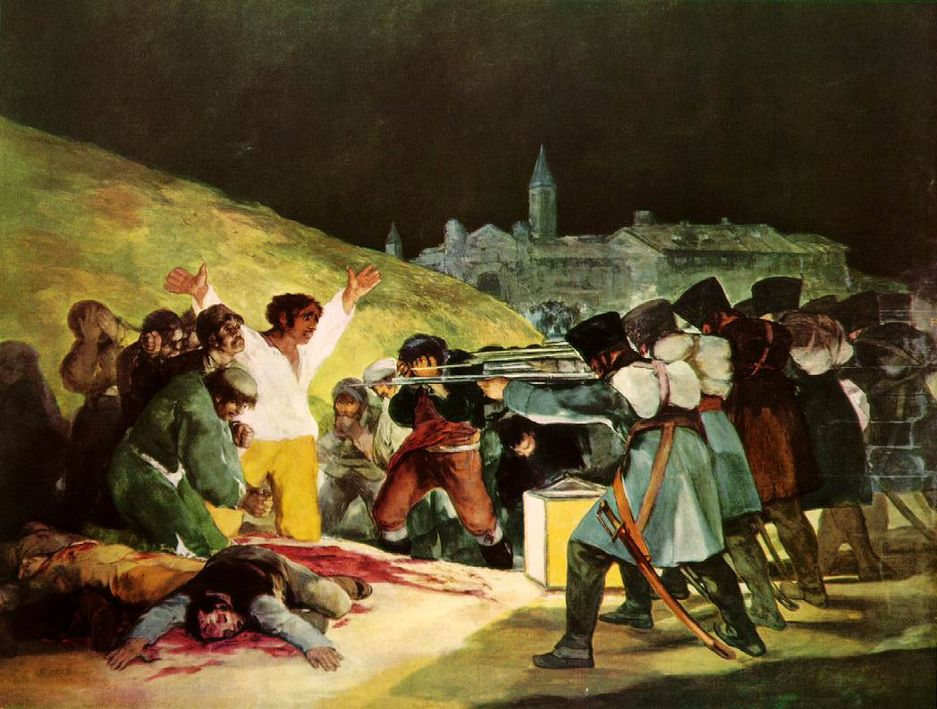

An informative documentary that delves deep into the genius of the brilliant 19th century Spanish master.

Goya, Los Rostros de (The Faces of) (32 Minutes) In Spanish
The soul of a genius and his era through his most interesting paintings.
Greco, El (30 Minutes) In Spanish **
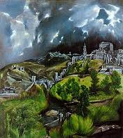

This film studies the universal figure of the great painter “El Greco.” He was born on the island of Crete and moved to Venice, Rome and Madrid before he finally settled in Toledo. His confrontation with King Felipe II, his fight to maintain his artistic identity and all the social, religious and political surroundings among which El Greco developed give us ground to analyze his work.

Headless Woman, The (87 Minutes) In Spanish w/ Subtitles
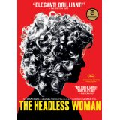
After running into something with her car, Vero experiences a particular psychological state. She realizes she might have killed someone.

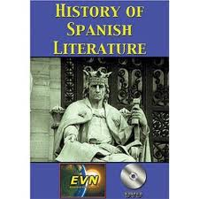
History of Spanish Literature, A (28 Minutes) In English

A film exploring the most noteworthy authors and literary genre periods of Spain through time.

Juan Carlos I, 10 años rey (83 Minutes) In Spanish
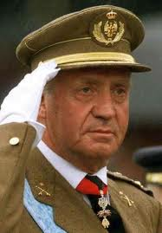

In 1985 Informe Semanal broadcast the comprehensive look at King Juan Carlos’ first 10 years as Spain’s ruler. Beginning with the transition after Franco’s death in 1975, the program examines the king’s initiatives to bring about a political reform and to promote national harmony. Extensive footage of the King’s political activities, speeches, public appearances alternate with an interview with him and clips of personal family history.

Libro del Buen Amor, El (Book of Good Love, The) (60 Minutes) In Spanish

Based on the book “The Book of Good Love.” The film focuses on the Melón-Endrina episode, weaving into it sections from the Arcipreste-Amor debate, the Gozos de Santa Maria and the Cantares de Ciegos. Northern Europeans have {-The Canterbury Tales} and {-The Decameron}, which are collections of stories written in the Middle Ages that paint a ribald and humorous picture of the amorous and other adventures of travelers in those times. Spain has El Libro de Buen Amor, written in the 14th century by the Archpriest of Hita, John Ruiz. This movie, starring Patxi Andion, a pop singer of the mid 1970s, retells several of its tales based on the courtship of a poet (Andion) and a noblewoman (Blanca Estrada) amid family opposition and the Black Plague.

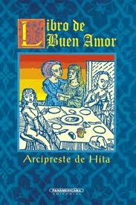
Literature of Spain, The (1975 to Present) (49 Minutes) In Spanish

With the death of Franco came a loosening of political restrictions and a restoration of many civil liberties. In this program, respected authorities look at the past twenty-five years of literature in post-Franco Spain and the literary inclinations of the next up-and-coming generation of poets, authors, and playwrights. Dramatic readers from the works of several of the most powerful writers of the period are included.
Lope de Vega: Fuenteovejuna (107 Minutes) In Spanish
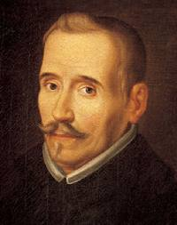

A play set in Medieval Spain that is enhanced on film by a lavish production. The essence of the work is realized on film as its author intended it, as it was meant to be viewed and not simply read.

Machado, Don Antonio Todavía (50 Minutes) In Spanish
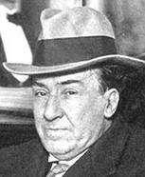

The beloved Spanish poet, Antonio Machado, is the subject of this biographical documentary, El Arte de Vivir: Don Antonio Todavía. Prompted by his posthumous reinstatement as a catedratico, this production profiles Machado and his work.

Mad Love (118 Minutes) Subtitles
The love story which transformed Joan (Juana), Queen of Spain, into Joan "The Mad". This is a story of passions, lies, and jealousy, which features a political fight at the center of it all.
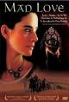

Madrid (30 Minutes) In English

Madrid beckons one and all with her diverse attractions. For lovers of art, the famous Prado museum offers the masterpieces of El Greco, Goya, and Velazquez. For those who enjoy energy and exuberance, there is the Puerta del Sol, full of lively cafes, or the Plaza Mayor, heart of old Madrid. For lovers of shopping, a search through the sale in the Ribera de Curtidores almost always uncovers a hidden treasure.

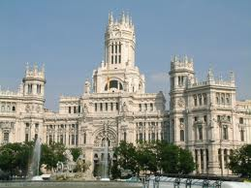
Mar Adentro, El (The Sea Inside) (125 Minutes) Subtitles
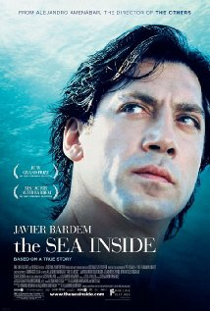
Life story of Spaniard Ramón Sampedro, who fought a 30-year campaign to win the right to end his life with dignity. Film explores Ramón's relationships with two women: Julia, a lawyer who supports his cause, and Rosa, a local woman who wants to convince him that life is worth living. Through the gift of his love, these two women are inspired to accomplish things they never previously thought possible. Despite his wish to die, Ramón taught everyone he encountered the meaning, value and preciousness of life. Though he could not move himself, he had an uncanny ability to move others.

Más Alla del Jardin (Beyond the Garden) (91 Minutes) In Spanish

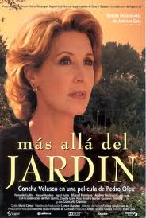

A melodrama about the midlife crisis of a Seville society hostess who has to come to terms with herself and her disintegrated family.

Monumental Cities of Spain (12 Minutes) In English **
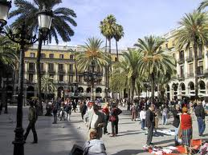

This film goes through the most noteworthy cities in Spain.

Mujeres al Borde de un Ataque de Nervios (Women on the Verge of a Nervous Breakdown) (89 Minutes) Subtitles
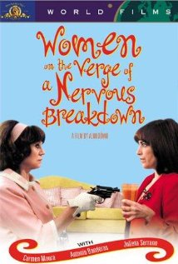

A woman's lover leaves her, and she tries to contact him to find out why he's left. She confronts his wife and son, who are as clueless as she. Meanwhile her girlfriend is afraid the police are looking for her because of her boyfriend's criminal activities. They talk to a female lawyer, who turns out to be the lover's new lover, and everyone's path keeps crossing each other's in a very complicated and confusing manner.

Ocho Apellidos Vascos (Eight Basque Surnames) (95 Minutes) Subtitles
Rafael, a Seville citizen who has never left the Spanish region of Andalucia, decides to leave his homeland to follow Amaia, a Basque girl unlike other women he has known.
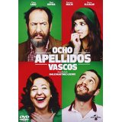
Pablo Picasso (85 Minutes) In Spanish
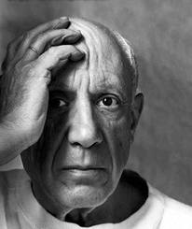

Pablo Picasso is portrayed through his art, historical footage that lays a background for his work, interviews with fellow artists Joan Miro, Hans Harting, and Edouard Pignon, and scenes of Picasso both at work and just relaxing. The narrative was created by Picasso’s friend Helene Parmelin, a journalist, and Jacqueline Picasso poses at the end surrounded by many of his canvasses, a testimony of his prolific career.

Picasso: Portrait of an Artist (82 Minutes) In English
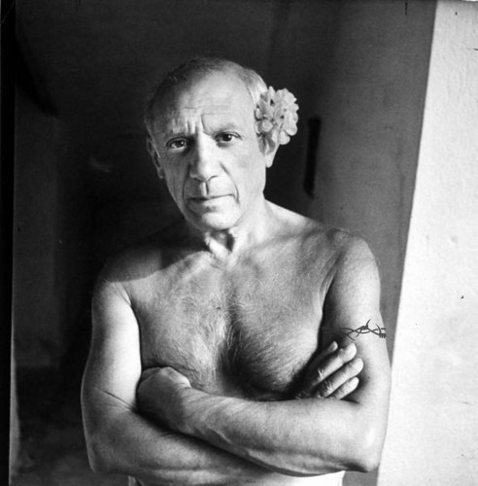
Centered around the opening of the Musee Picasso in Paris, this film takes the opportunity to examine the collection created by Picasso, the work he felt to be his personal legacy to the world. The powerful spirit of the artist is echoed in the dramatic theater of Corrida, the ring of the bullfight, and in the images of regional Spain-Gosol, Malaga, Barcelona.
Piel Que Habito, La (The Skin I Live in)(120 Minutes) (Subtitles)

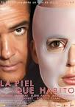

In honor of his late wife who died in a flaming car accident, Dr. Robert Ledgard is trying to synthesize the perfect skin, which can withstand burns, cuts and any other kind of damage. As he gets closer to perfecting this skin on his flawless patient, the scientific community starts growing skeptical and his past is revealed that shows how his patient is closely linked to tragic events he would like to forget.
Ponce de León (50 Minutes) In English

Mention the name Ponce de León, and most people will recall his futile search the mythical Fountain of Youth. But there is far more to the life of the great explorer than just a single event out of history. In this enlightening biography, the full story of the Spaniard’s quest for wealth, power, and eternal youth is discovered by retracing his quest and conquests in the New World. Ponce de León gained fame when he voyaged to the Americas with Columbus in the 16th Century. There, he discovered Florida and served as Puerto Rico’s first governor. Soldier, explorer, and visionary, Ponce de León is a legend for all times.

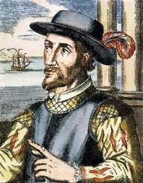

Próximo Oriente, El (The Near East) (95 Minutes) In Spanish

A well-intending butcher from Madrid steps in to right a wrong made by his overconfident sibling, and as the problems begin to snowball the comedy turns to screwball in veteran Spanish writer/director Fernando Colomo’s humorous take on multiculturalism in the Spanish capitol. Cain (Javier Cifrian) is a butcher from the barrio who has never had much luck in love. Cain’s married brother Abel (Asier Etxeandia), on the other hand, seems to have the exact opposite problem. An annoyingly overconfident womanizer who has recently impregnated pretty Muslim Aisha (Nur Al Levi), Abel refuses to take responsibility for the unborn child. When Cain learns that he will have to convert to Islam for the marriage to take place, however, the cultural differences between Cainand Aisha’s families grow increasingly pronounced.

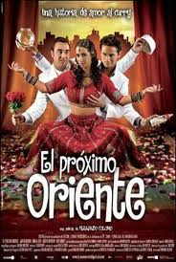
Pueblos del Caballo, Los (Favorite, The) (56 Minutes) In Spanish

The discovery that Angela, a student in the high school, is addicted to heroine created turmoil in her family, among her professors, and in the school community at large. Yet as her parents and others come to grips with her problem, their own personal faults are revealed. While Angela’s prospects for recovery remain good, the situation of her friend Gabriel offers less hope.
Religión y el Hombre, La (55 Minutes) In Spanish

A non-traditional look at the Christmas holidays, this episode examines the many conflicts that arise between individuals and social tradition. From public life to private life these conflicts embroil friends, colleagues and families. In order to reconcile their differences, some surprising concessions are made.
Retrato de Familia (Family Portrait) (110 Minutes) In Spanish

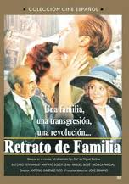
This film follows the experiences of a Spanish family living near the Portuguese border at the time of the outbreak of the Spanish Civil War in February of 1936. The story also reveals the long-standing romantic rivalry between the father and the son of the family, as well as their mutual caring and esteem. Besides tension within the family, the movie also shows the general tension just before the war in the episodes that take place in a local cabaret.

Rick Steves’ Europe (Disc 2) (30 Minutes) In English
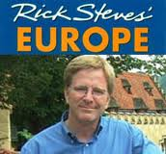

The charismatic Rick Steves stocks up on the sun block to take in the sights and sounds of Portugal and Spain in this informative release. In Spain he looks at Barcelona, Madrid, the Basque Region, Sevilla, and several smaller resorts; while in Portugal, Steves makes the journey out to Lisbon, The Algarve, Porto, Nazare, and many other places. Perfect for folks looking to venture to Europe for a vacation, this is another useful guide from Rick Steves.

Rick Steve’s Spain (210 Minutes) In English
You can count on Rick Steves to tell you what you really need to know when traveling in Spain.
In this guided video, you’ll find an inviting mix of exciting cities and cozy towns. Explore the lively cities of Madrid, Barcelona, and Seville, and follow the Route of the White Hill Towns in Andalucía’s sun-drenched countryside. Experience the works of the great masters—from El Greco to Picasso to Dalí—and learn how to avoid the lines at the most popular museums. Self-guided walks lead you through the castles, cathedrals, and villages of this ancient but modern land. End your day with a glass of Rioja wine and a plate of tapas—then join the locals for an evening of flamenco.
Rick’s candid, humorous advice will guide you to good-value hotels and restaurants. He’ll help you plan where to go and what to see, depending on the length of your trip. You’ll get up-to-date recommendations about what is worth your time and money.

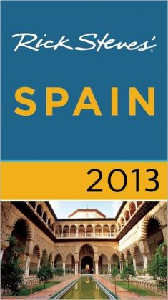

Secretos del Corazón (Secrets of the Heart) (105 Minutes) In Spanish
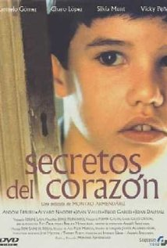

Javi is a nine-year-old living in a small town in the early 1960s. He becomes fascinated by the idea that he can hear ghosts, especially in the room where his father died. Javi begins to investigate his family life and learns a great deal about his mother, uncle, and aunts. Delicate story of childhood, nominated for the academy Award for Best Foreign Film.
The Secret in Their Eyes (129 Minutes) In Spanish
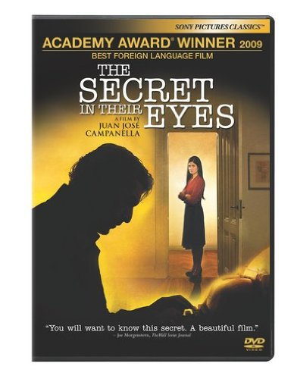
A retired legal counselor writes a novel hoping to find closure for one of his past unresolved homicide cases and for his unreciprocated love with his superior – both of which still haunt him decades later

Sevillanos de Carlos Saura (52 Minutes) In Spanish

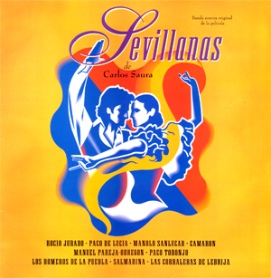

Filmed like a documentary, “Sevillanas” consists of eleven short performances by Spain’s most famous flamenco dancers, singers and guitarists. Saura, well-known for his flamenco films (“Blood Wedding”, “Carmen”) provides an in-depth look at the Sevillanas form of flamenco and its dancers.
Seville CC-CS (23 Minutes) In English
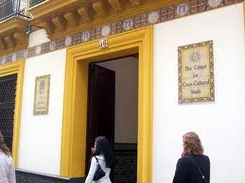

Cultural Film exploring the Seville Study Abroad program.

Solas (Alone) (105 Minutes) In Spanish
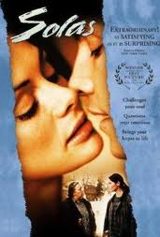

Maria, whose parents live in the country, cannot stand her father's authoritarian ways and moves to the city. She finds a job as a cleaner and tries to survive in a wretched apartment in the shabby part of a big city. She is pregnant, and the fact that her boyfriend has abandoned her does not help matters. When her father goes to the hospital for an operation, her mother comes to stay with her. Her neighbor, an old recluse whose only friend is his dog, begins to come out of his shell and these three lost souls try to give each other the strength to start over.

Spain: Everything Under the Sun (50 Minutes) In English
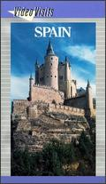

The thought of Spain conjures up images of bullfights, flamenco dancers, and sunny skies. In this film, Video Visits: Spain: Everything Under the Sun, would-be travelers and those merely curious about the country can find a rich sampling of the sights and sounds that are uniquely Spain. The major cities include Seville, Toledo, Barcelona, Madrid, and Granada, and travelers will find many diversions in each locale. The flavor of Spain can be spicy, and the many restaurants offer memorable dishes to savor.

Spain: The Moorish Influence (28 Minutes) In English
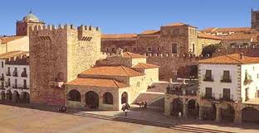

In A.D. 711 the warriors of Islam swept into Spain, their spectacular conquest coalescing into an empire of great strength and refinement. For eight hundred years, “Al Andaluz” fascinated Northern Europe and was known as “The Jewel of the World.” This program encompasses Spain’s epic story of conquest and re-conquest at the crossroads of two worlds. Filmed throughout Spain and Morocco, the program vividly describes the shifting social and political realities of the Islamic and Christian kingdoms.

Spanish Kitchen, The (30 Minutes) In English
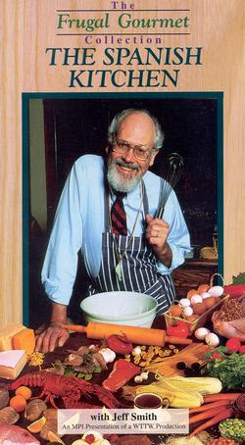

Spicy Spanish cuisine: cold tomato soup, garlic and egg soup, chicken and chick-pea stew and paella.
Spanish Literature Under Dictatorship: 1940-1975 (50 Minutes) In Spanish

How did life in post-civil war Spain—a time of uncertainty and oppression—influence the writings of the period? In this program, renowned experts explore the literature of the Franco era through the experiences of Ana María Matute and other writers who chose to stay in Spain after the Nationalist victory in 1939. Dramatic readings include excerpts from Camilo José Cela’s La Colmena, Luis Martín-Santos’s Tiempo de Silencio, Carmen Martín Gaite’s Entre Visillos, Miguel Delibes’ Cinco Horas con Mario, and Gonzalo Torrente Ballester’s Don Juan, as well as from the works of Matute, Jaime Gil de Biedma, and José Angel Valente.
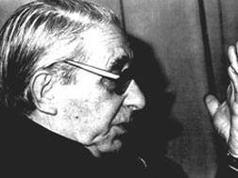
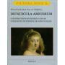
Spanish Painting Set 1&2 (30 Minutes)
Art film.

Te Doy Mis Ojos (Take My Eyes) (107 Minutes) In Spanish

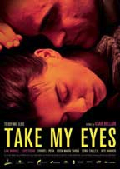
A couple breaks up after the husband's violent and abusive nature finally becomes too much for his wife, but the breakup becomes a rebuilding experience for both of them as they pick up the tattered remains of their lives. TAKE MY EYES won seven prestigious Goya Awards--the Spanish equivalent of the Oscars.

Telerrevista (1974) (28 Minutes) In Spanish
Cultural video.

Tesis (Thesis) (121 Minutes) (Subtitles)
Why are death and violence so fascinating? Is it morally correct to show violence in movies? If so, is there a limit to what or how much we should show? That's the subject of Ángela's examination paper. She is a young student at a film school in Madrid. Together with the help of another student, Chema (who is obsessed with violent movies), they find a “snuff” movie in which a young girl is tortured and killed on camera. Soon they discover that the girl was a former student at their school, and that the school’s administration may be trying to cover up her disappearance and death.
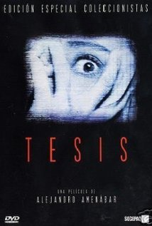

Todo Sobre me Madre (All About My Mother) 102 Minutes In Spanish

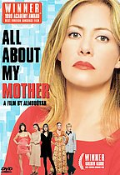
Distraught over the death of her teenage son, Manuela drives to Barcelona to find the boy’s father, an inherent transsexual named Lola (Toni Canto). While combing the cities less reputable districts, she also meets up with Agrado (Antonio San Juan), a sassy transvestite prostitute, and Rosa (Penelope Cruz), a pregnant nun on her way to El Salvador. She also becomes the manager for Huma (Marissa Paredes), these great ladies bond through various heartrending crises, enduring the pain and celebrating the beauty of being women (or almost women).

Understanding Don Quixote (2004) (21 Minutes) In English **
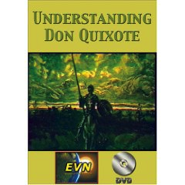
A literature film about Don Quixote.

Velazquez (56 Minutes) In Spanish

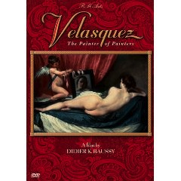
A portrait of the extraordinary painter who chronicled the life and times of his friend King Philip the Fourth, who built the core of the Prado Collection, and who is one in the quartet of the greatest painters of Spain.

Volver (To Return) (121 Minutes) In Spanish
** Only have original VHS tape; Advance arrangements are to be made with Dept. Assistant in order to view this tape
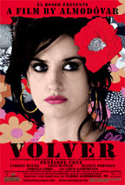
Paimunda and her sister Sole lost their parents in a tragic fire years ago… or did they? Superstitious villagers claimed that the girls’ departed mother, Irene (Maura), has been seen wandering around their Aunt Paula’s home. When Irene appears to Sole, she explains that she has returned to set right her daughters’ troubled lives and reveals shocking secrets that will impact everyone! Raimunda has “female troubles” of her own, least of which is a corpse in the freezer!

